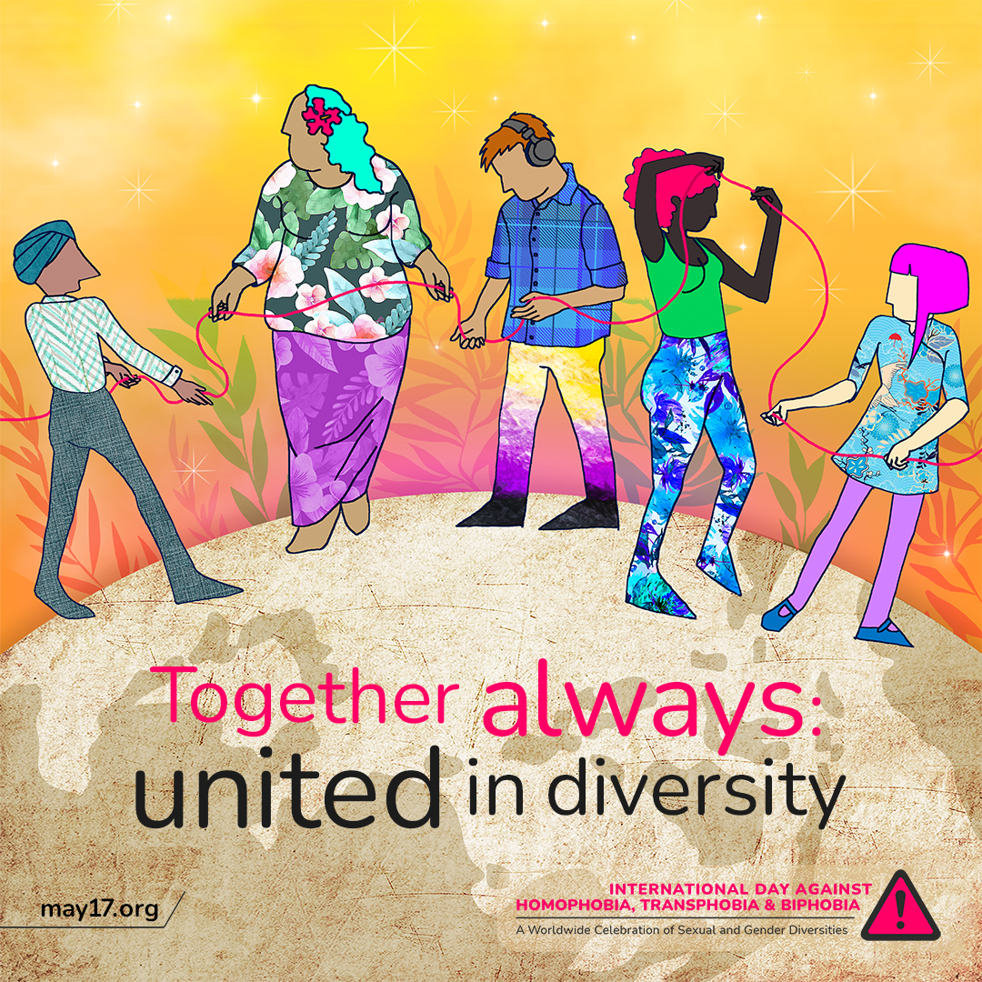

|  |
| --- |
| On the International Day Against Homophobia, Transphobia, and Biphobia, we recognise the intersectional discrimination that LGBTQIA+ people face. 💛🏳️‍🌈  We pledge to uplift and centre the voices of LGBTQIA+ individuals who face additional barriers, such as racism, ableism, and poverty. Let's continue to work towards a world that is truly inclusive and respectful.  #IDAHOBIT2023 #IDAHOBIT |