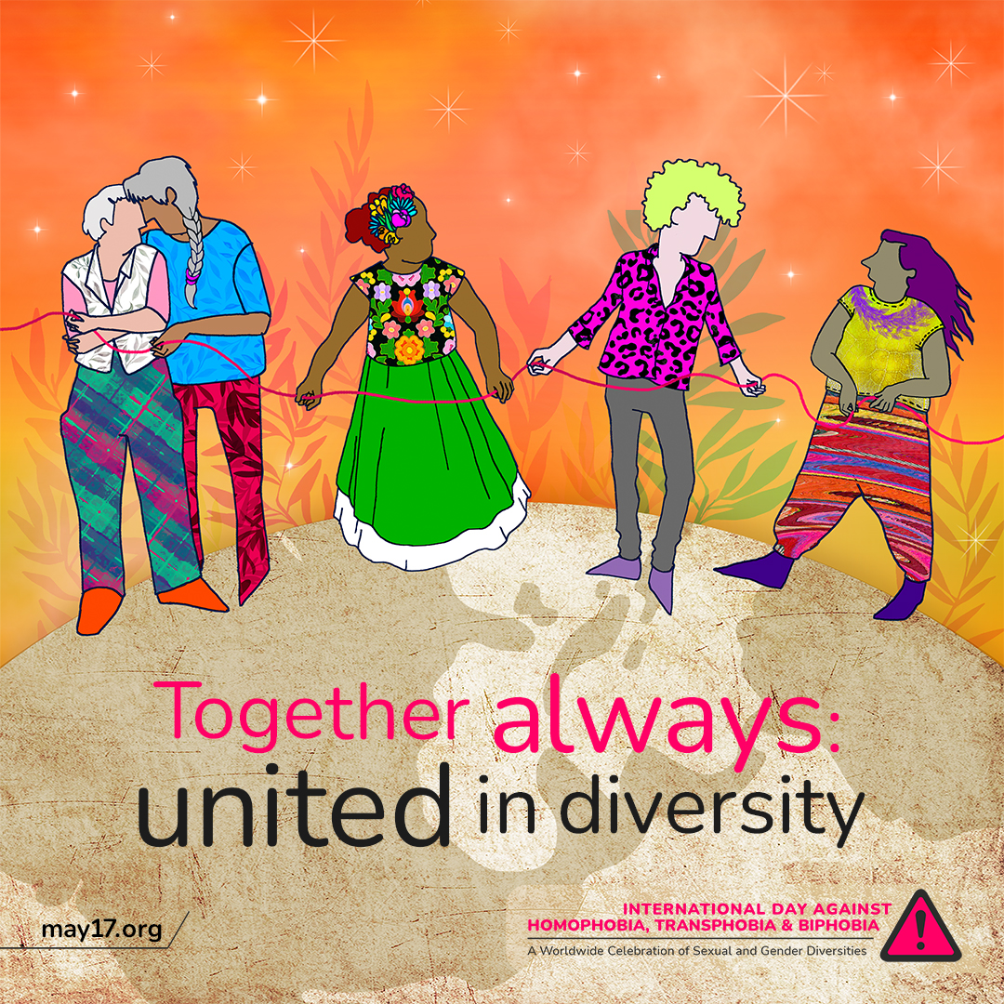
This International Day Against Homophobia, Transphobia, and Biphobia, we celebrate the resilience and strength of the LGBTQIA+ community. We honour the countless activists and advocates who have fought for our rights and paved the way for progress. Let's remain together in our demand for equality and justice for all. 🧡🏳️‍🌈

#IDAHOBIT2023 #IDAHOBIT

