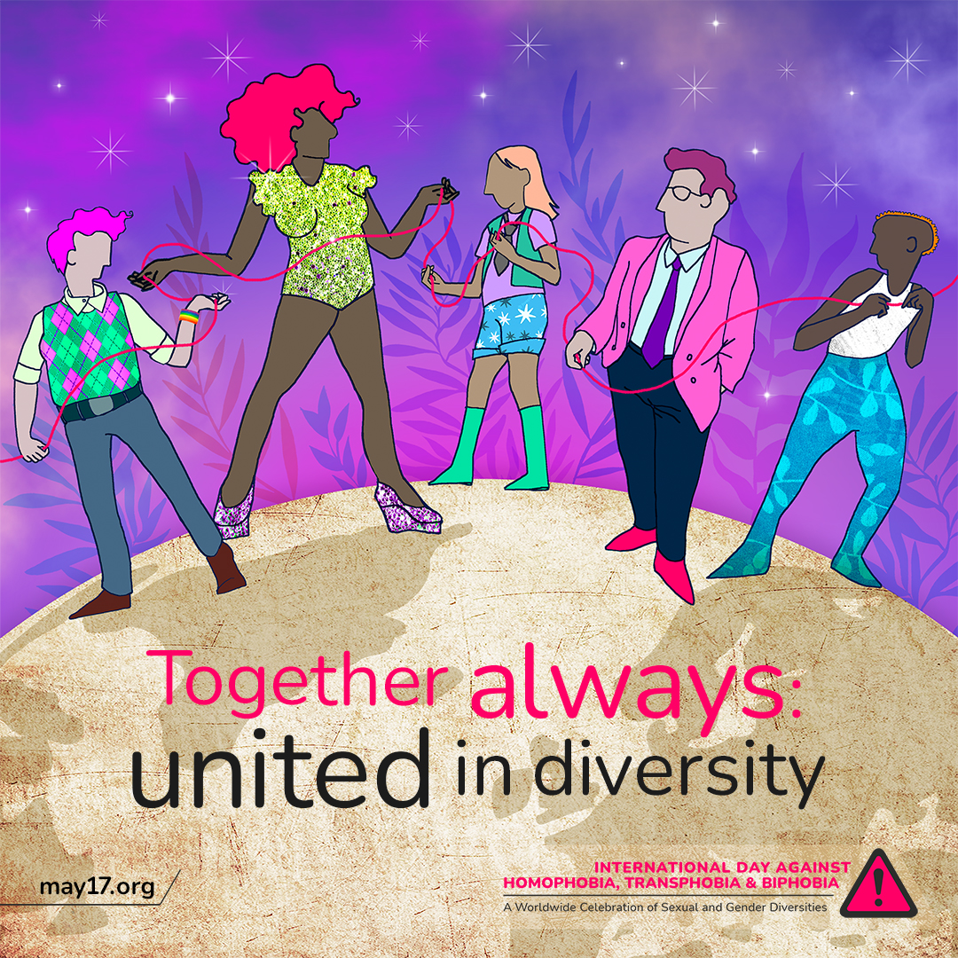

The International Day Against Homophobia, Transphobia, and Biphobia is around the corner! 💜🏳️‍🌈
Today, we reaffirm our right to live free from discrimination and violence. Let's continue to raise awareness and advocate for a world that celebrates diversity and promotes equality for all.

#IDAHOBIT2023 #IDAHOBIT

