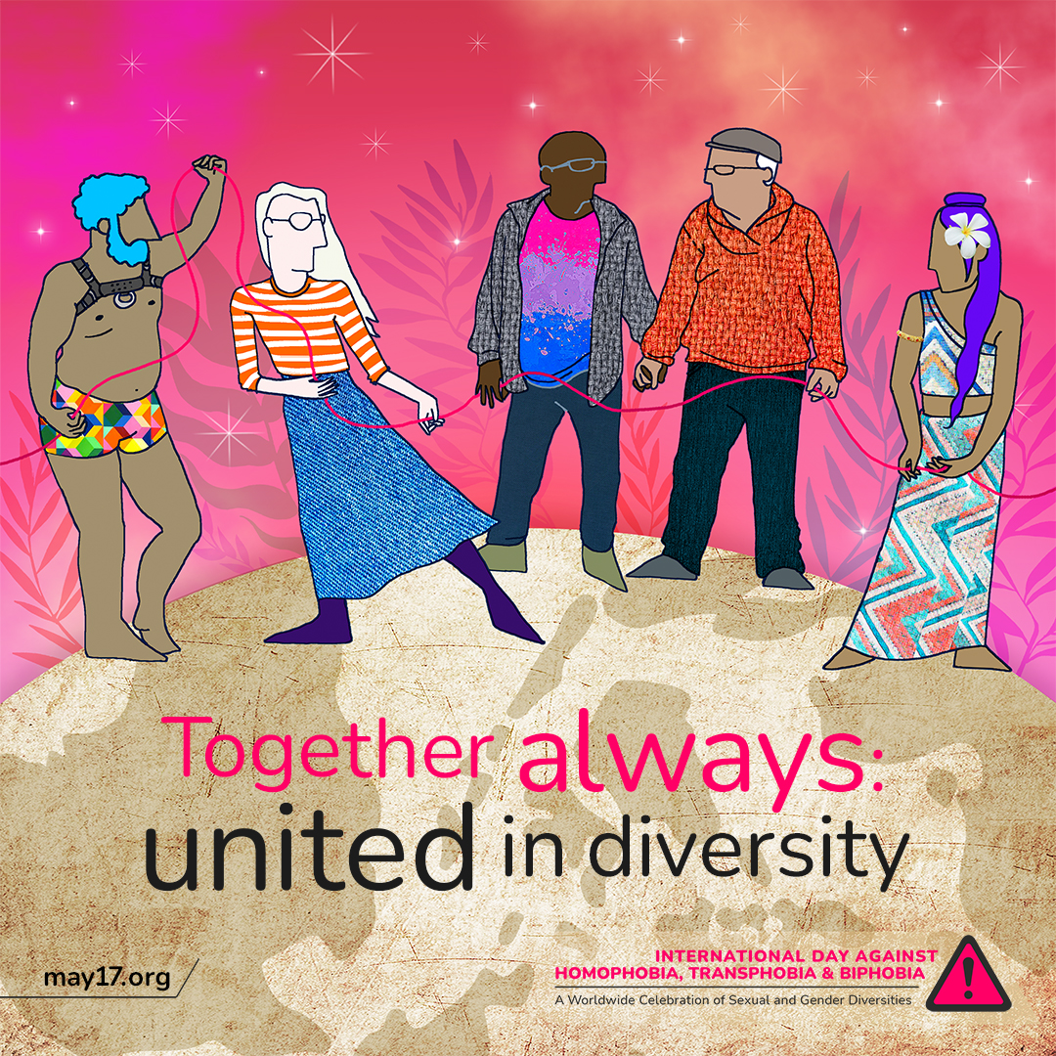

|  |
| --- |
| On this International Day Against Homophobia, Transphobia, and Biphobia, let's pledge to support our LGBTQIA+ loved ones. Together, we can break down the stigma and create a safe and respectful community for everyone. ❤️🏳️‍🌈  #IDAHOBIT2023 #IDAHOBIT |