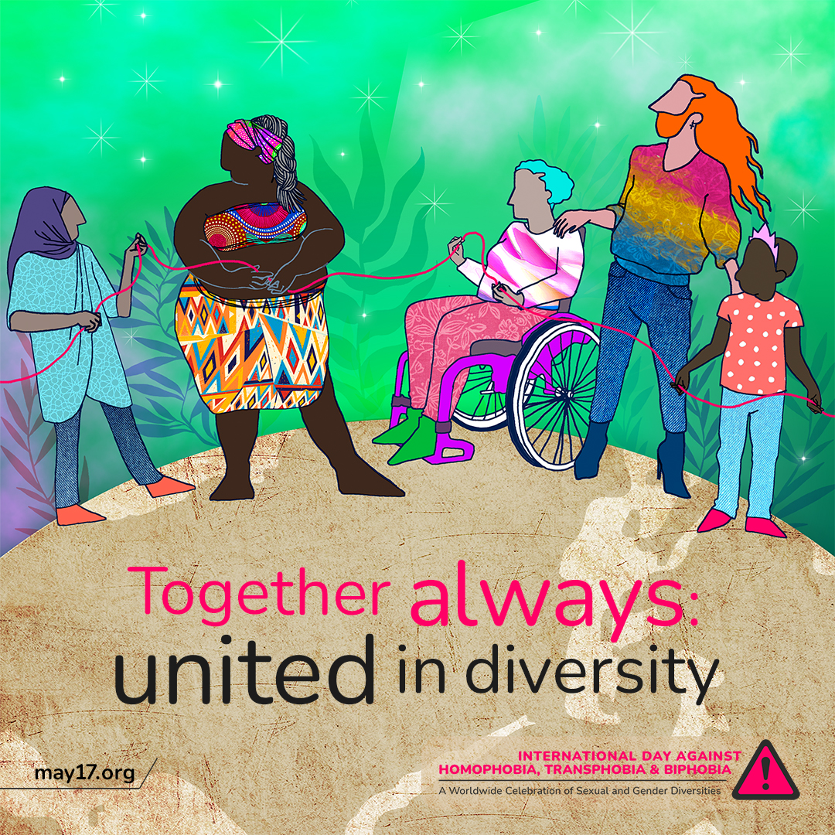
On this International Day Against Homophobia, Transphobia, and Biphobia, we call for healthcare systems that are inclusive and responsive to the needs of the LGBTQIA+ community. 💚🏳️‍🌈
Let's work towards a world where everyone, regardless of their gender identity or sexual orientation, can access quality healthcare without fear of discrimination or stigma.

#IDAHOBIT2023 #IDAHOBIT

